ETC2410 Assignment 1

David Kontrobarsky, Amy Corrone, Wendy Huynh, Chandralekha Segaran, Joshua Bunce

31 August 2018

# QUESTION 1

Assumptions for all estimators:

## a)

$$\begin{matrix}Population relationships: \\ y_{t}=β_{0}+β_{1}x_{t}+u_{t} \\ \overline{y}=β_{0}+β_{1}\overline{x}+\overline{u} \\ Y_{1}=β_{0}+β_{1}x_{1}+u_{1} (First observation) \\ Y_{n}=β_{0}+β_{1}x_{n}+u_{n} (Last observation)\end{matrix}$$

$$E(u | X)=0$$

### 1.)

$$\begin{matrix}\overset{^}{β^{[1]}}=\frac{\frac{1}{n}\sum_{t=1}^{n}{y_{t}}}{\frac{1}{n}\sum_{t=1}^{n}{x_{t}}}\end{matrix}$$

$$\begin{matrix}=\frac{\sum_{t=1}^{n}{y_{t}}}{\sum_{t=1}^{n}{x_{t}}}\end{matrix}$$

Substitute $y_{t}$ from above:

$$\begin{matrix}=\frac{\sum_{t=1}^{n}{β_{0}}+β_{1}x_{t}+u_{t}}{\sum_{t=1}^{n}{x_{t}}}\end{matrix}$$

Convert to a sum of fractions and take $β_{1}$ out of the sum

$$=\frac{β_{1}\sum_{t=1}^{n}{x_{t}}}{\sum_{t=1}^{n}{x_{t}}}+\frac{\sum_{t=1}^{n}{β_{0}}}{\sum_{t=1}^{n}{x_{t}}}+\frac{\sum_{t=1}^{n}{u_{t}}}{\sum_{t=1}^{n}{x_{t}}}$$

$$=β_{1}+\frac{\sum_{t=1}^{n}{β_{0}}}{\sum_{t=1}^{n}{x_{t}}}+\frac{\sum_{t=1}^{n}{u_{t}}}{\sum_{t=1}^{n}{x_{t}}}$$

Take expectations conditional on x:

$$\begin{matrix}E[{\overset{^}{β}}_{1}^{[1]}|x]=E[β_{1}]+E[\frac{\sum_{t=1}^{n}{β_{0}}}{\sum_{t=1}^{n}{x_{t}}}]+E[\frac{\sum_{t=1}^{n}{u_{t}}}{\sum_{t=1}^{n}{x_{t}}}] \\ \\ =β_{1}+E[\frac{\sum_{t=1}^{n}{β_{0}}}{\sum_{t=1}^{n}{x_{t}}}]+E[\frac{\sum_{t=1}^{n}{u_{t}}}{\sum_{t=1}^{n}{x_{t}}}] \\ Note:\sum_{t=1}^{n}{β_{0}}=nβ_{0} \\ =β_{1}+E[\frac{nβ_{0}}{\sum_{t=1}^{n}{x_{t}}}]+E[\frac{\sum_{t=1}^{n}{u_{t}}}{\sum_{t=1}^{n}{x_{t}}}] \\ \\ \\ =β_{1}+E[\frac{nβ_{0}}{\sum_{t=1}^{n}{x_{t}}}]+\frac{1}{\sum_{t=1}^{n}{x_{t}}}E[\sum_{t=1}^{n}{u_{t}}] \\ Because\sum_{t=1}^{n}{x_{t}} can be treated as a constant given x \\ =β_{1}+\frac{nβ_{0}}{\sum_{t=1}^{n}{E}[x_{t}]}+\frac{1}{\sum_{t=1}^{n}{x_{t}}}\sum_{t=1}^{n}{E}[u_{t}|X] \\ Because the expectation of a sum is equal to the sum of indiviudal expectations \\ =β_{1}+\frac{nβ_{0}}{\sum_{t=1}^{n}{E}[x_{t}]} \\ Because E[ u | X]=0⟹E[ u_{t} | X]=0 \\ =β_{1}+\frac{nβ_{0}}{\sum_{t=1}^{n}{x_{t}}} \\ Because the expectation of a constant is the constant itself \end{matrix}$$

Therefore $\overset{^}{β^{[1]}}=\frac{\frac{1}{n}\sum_{t=1}^{n}{y_{t}}}{\frac{1}{n}\sum_{t=1}^{n}{x_{t}}}$ is not an unbiased estimator of $β_{1}$

### 2.)

$${\overset{^}{β}}_{1}^{[2]}=\frac{y_{n}-y_{1}}{x_{n}-x_{1}}$$

Substitute $Y_{n} and Y_{n}$ from above and simplify:

$$\begin{matrix}{\overset{^}{β}}_{1}^{[2]}=\frac{\left(β_{0}+β_{1}x_{n}+u_{n})-(β_{0}+β_{1}x_{1}+u_{1}\right)}{\left(X_{n}-X_{1}\right)} \\ =\frac{\left(β_{1}x_{n}+u_{n}-β_{1}x_{1}-u_{1}\right)}{\left(X_{n}-X_{1}\right)}\end{matrix}$$

Factorise the $β_{1}$ terms and convert to a sum of fractions then simplify:

$${\overset{^}{β}}_{1}^{[2]}=\frac{\left(β_{1}(x_{n}-x_{1})+u_{n}-u_{1}\right)}{\left(X_{n}-X_{1}\right)}$$

$${\overset{^}{β}}_{1}^{[2]}=\frac{\left(β_{1}(X_{n}-X_{1})\right)}{\left(X_{n}-X_{1}\right)}+\frac{u_{n}-u_{1}}{(X_{n}-X_{1})}$$

$${\overset{^}{β}}_{1}^{[2]}=β_{1}+\frac{u_{n}-u_{1}}{(X_{n}-X_{1})}$$

Now take expectations conditional on X:

$$\begin{matrix}E[{\overset{^}{β}}_{1}^{[2]}|X]=E[β_{1}]+E[\frac{u_{n}-u_{1}}{(X_{n}-X_{1})}] \\ Because the expectation of a sum is equal to the sum of indiviudal expectations \\ =β_{1}+\frac{1}{X_{n}-X_{1}}E[u_{n}-u_{1}] \\ Because the X terms can be treated as constants given X \\ =β_{1}+\frac{1}{X_{n}-X_{1})}E[u_{n}]-\frac{1}{X_{n}-X_{1}}E[u_{1}] \\ =β_{1}+0+0 \\ Because E[ u | X]=0⟹E[ u_{1} | X]=0 and E[ u_{n} | X]=0 \\ =β_{1}\end{matrix}$$

Therefore ${\overset{^}{β}}_{1}^{[2]}=\frac{y_{n}-y_{1}}{x_{n}-x_{1}}$ is an unbiased estimator of $β_{1}$

### 3.)

$${\overset{^}{β}}_{1}^{[3]}=\frac{y_{n}-\overline{y}}{x_{n}-\overline{x}}$$

Substitute $Y_{n} and Y_{n}$ from above and simplify:

$$\begin{matrix}{\overset{^}{β}}_{1}^{[3]}=\frac{\left(β_{0}+β_{1}x_{n}+u_{n}-(β_{0}+β_{1}\overline{x}+\overline{u})\right)}{\left(X_{n}-\overline{X}\right)} \\ =\frac{\left(β_{1}x_{n}+u_{n}-β_{1}\overline{x}-\overline{u}\right)}{\left(X_{n}-\overline{X}\right)}\end{matrix}$$

Factorise the $β_{1}$ terms and convert to a sum of fractions then simplify:

$${\overset{^}{β}}_{1}^{[3]}=\frac{\left(β_{1}(x_{n}-\overline{x})+u_{n}-\overline{u}\right)}{\left(X_{n}-\overline{x}\right)}$$

$${\overset{^}{β}}_{1}^{[3]}=\frac{β_{1}(X_{n}-\overline{X})}{\left(X_{n}-\overline{X}\right)}+\frac{u_{n}-\overline{u}}{(X_{n}-\overline{X})}$$

$${\overset{^}{β}}_{1}^{[3]}=β_{1}+\frac{u_{n}-\overline{u}}{(X_{n}-\overline{X})}$$

Now take expectations conditional on X:

$$\begin{matrix}E[{\overset{^}{β}}_{1}^{[3]}|X]=E[β_{1}]+E[\frac{u_{n}-\overline{u}}{(X_{n}-\overline{X})}] \\ Because the expectation of a sum is equal to the sum of indiviudal expectations \\ =β_{1}+\frac{1}{X_{n}-\overline{X}}E[u_{n}-\overline{u}] \\ Because the X terms can be treated as constants given X \\ =β_{1}+\frac{1}{X_{n}-X_{1}}E[u_{n}]-\frac{1}{X_{n}-X_{1})}E[\overline{u}] \\ =β_{1}+0+0 \\ Because E[ u | X]=0⟹E[ u_{n} | X]=0 and E[ \overline{u} | X]=0 \\ =β_{1}\end{matrix}$$

Therefore ${\overset{^}{β}}_{1}^{[3]}=\frac{y_{n}-\overline{y}}{x_{n}-\overline{x}}$ is an unbiased estimator of $β_{1}$

### 4.)

$${\overset{^}{β}}_{1}^{[4]}=\frac{{\overset{^}{σ}}_{x,y}}{{\overset{^}{σ}}_{x}^{2}}=\frac{Cov(X,Y)}{Var(X)}$$

Rewrite the covariance and variance as their respective definitions:

$$Cov(X,Y)={\overset{^}{σ}}_{x,y}=\frac{\sum_{t=1}^{n}{\left(X_{t}-\overline{X}\right)}\left(Y_{t}-\overline{Y}\right)}{n-1}$$

$$Var(X)={\overset{^}{σ}}_{x}^{2}=\frac{∑(X-\overline{X})^{2}}{n-1}$$

$${\overset{^}{β}}_{1}^{[4]}=\frac{\frac{\sum_{i=1}^{n}{\left(X_{t}-\overline{X}\right)}\left(Y_{t}-\overline{Y}\right)}{n-1}}{\frac{∑(X-\overline{X})^{2}}{n-1}}$$

Simplify:

$${\overset{^}{β}}_{1}^{[4]}=\frac{\sum_{t=1}^{n}{\left(X_{t}-\overline{X}\right)}\left(Y_{t}-\overline{Y}\right)}{\sum_{t=1}^{n}{{\left(X_{t}-\overline{X}\right)}^{2}}}$$

Substitute $Y_{t} and \overline{Y}$ from above and simplify the expression:

$$\begin{matrix}{\overset{^}{β}}_{1}^{[4]}=\frac{\sum_{t=1}^{n}{\left(X_{t}-\overline{X}\right)}\left(β_{0}+β_{1}x_{t}+u_{t}-(β_{0}+β_{1}\overline{x}+\overline{u})\right)}{\sum_{t=1}^{n}{{\left(X_{t}-\overline{X}\right)}^{2}}} \\ =\frac{\sum_{t=1}^{n}{\left(X_{t}-\overline{X}\right)}\left(β_{1}(X_{t} - \overline{X})+u_{t}-\overline{u})\right)}{\sum_{t=1}^{n}{{\left(X_{t}-\overline{X}\right)}^{2}}}\end{matrix}$$

Simplify further, take individual sums and take out constant terms:

$$\begin{matrix}{\overset{^}{β}}_{1}^{[4]}=\frac{β_{1}\sum_{t=1}^{n}{{\left(X_{t}-\overline{X}\right)}^{2}}+\sum_{t=1}^{n}{\left(X_{t}-\overline{X}\right)}\left(u_{t}-\overline{u})\right)}{\sum_{t=1}^{n}{{\left(X_{t}-\overline{X}\right)}^{2}}} \\ =\frac{β_{1}\sum_{t=1}^{n}{{\left(X_{t}-\overline{X}\right)}^{2}}+\sum_{t=1}^{n}{\left(X_{t}-\overline{X}\right)}u_{t}-\left(\overline{u}\sum_{t=1}^{n}{\left(X_{t}-\overline{X}\right)}\right)}{\sum_{t=1}^{n}{{\left(X_{t}-\overline{X}\right)}^{2}}}\end{matrix}$$

*Note: $\sum_{t=1}^{n}{\left(X_{t}-\overline{X}\right)}=0 because \sum_{t=1}^{n}{X_{t}}-\sum_{t=1}^{n}{\overline{X}}=n\overline{X}-n\overline{X}=0$*

$$\begin{matrix}{\overset{^}{β}}_{1}^{[4]}=\frac{β_{1}\sum_{t=1}^{n}{{\left(X_{t}-\overline{X}\right)}^{2}}+\sum_{t=1}^{n}{\left(X_{t}-\overline{X}\right)}u_{t}}{\sum_{t=1}^{n}{{\left(X_{t}-\overline{X}\right)}^{2}}} \\ =\frac{β_{1}\sum_{t=1}^{n}{{\left(X_{t}-\overline{X}\right)}^{2}}}{\sum_{t=1}^{n}{{\left(X_{t}-\overline{X}\right)}^{2}}}+\frac{\sum_{t=1}^{n}{\left(X_{t}-\overline{X}\right)}u_{t}}{\sum_{t=1}^{n}{{\left(X_{t}-\overline{X}\right)}^{2}}}\end{matrix}$$

$$=β_{1}+\frac{\sum_{t=1}^{n}{\left(X_{t}-\overline{X}\right)}u_{t}}{\sum_{t=1}^{n}{{\left(X_{t}-\overline{X}\right)}^{2}}}$$

Now take expectations conditional on X:

$$\begin{matrix}E[{\overset{^}{β}}_{1}^{[4]}|X]=E[β_{1}]+E[\frac{\sum_{t=1}^{n}{\left(X_{t}-\overline{X}\right)}u_{t}}{\sum_{t=1}^{n}{{\left(X_{t}-\overline{X}\right)}^{2}}}] \\ Because the expectation of a sum is equal to the sum of indiviudal expectations\end{matrix}$$

$$\begin{matrix} =β_{1}+\frac{1}{\sum_{t=1}^{n}{\left(X_{t}-\overline{X}\right)}}E[u_{t}] \\ Because the X terms can be treated as constants given X \end{matrix}$$

$$E[ u | X]=0⟹E[ u_{t} | X]=0 for all t$$

$$E[{\overset{^}{β}}_{1}^{[4]}|X]=β_{1}+0=β_{1}$$

Therefore ${\overset{^}{β}}_{1}^{[4]}=\frac{{\overset{^}{σ}}_{x,y}}{{\overset{^}{σ}}_{x}^{2}}$ is an unbiased estimator of $β_{1}$

## b)

The variance of the unexplained component (error) of excess returns of Qantas, conditional on the excess returns of the market portfolio is constant for all values of excess return of the market portfolio.

That is, $Var[ u |X]=σ^{2}I_{n}$ where u is the unexplained component of excess return of Qantas, X is the excess returns of the market portfolio and $I_{n}$ is an identity matrix. This assumption also implies that the covariance of all the error terms is 0 i.e they are independent. A residual plot without any systematic pattern would be a good indicator of independence.

This means that the error term of the excess returns of Qantas is normally distributed, $u∼N(0,σ^{2})$

If this is the case then the error of the excess return of Qantas is homoskedastic and the OLS estimator will have a smaller variance than all the other estimators.

# 

# Question 2

#### 1. Introduction

In 2015, it was estimated that 526,000 child deaths were caused by diarrhoeal infections. This is a vast improvement from the estimated figure of 1.2 million in the year 2000 which is in part due to initiatives by the World Health Organisation(WHO) and UNICEF. Diarrhea and other water-borne diseases remain to be a deadly threat currently but are believed to be largely preventable. The WHO believes that better water and sanitation could save 361,000 children under 5 each year. Studies have shown that contaminated water and minimal sanitation are related to the spread and transmission of diarrhea and other deadly diseases such as cholera, dysentery, hepatitis A and typhoid. Inadequate or inappropriately managed water and sanitation services increase the transmission of these diseases, and the exposure of children to these preventable health risks. Improvements in water infrastructure and sanitation have been promoted as fundamental public health measures to better the overall health of the population. If piped and regulated water supplies were to be achieved around the world, about 7.6 billion cases of diarrhea could be prevented each year as well as other diseases, this represents a 70% reduction. These are essential interventions for the health of the populations and of younger children in particular.

These preventative actions have proven effective in the past. Chicago and other American cities saw major decreases in under 5 mortality, mainly attributed to water purification procedures which led to the eradication of diarrheal diseases and other water based diseases. Research in 2001 by North Western and George Mason University’s concluded that water infrastructure in particular, efforts to move water intakes far from sewage outflows were the main driving force in reducing water-related mortality.

Evidence outlined below from WHO data suggests funding to infrastructure that improves water and sanitation services could significantly decrease under 5 mortality rate.

**2. Quantitative analysis**

**a)**

The data to be used in this report comes from the World Development Indicators dataset. 40 countries were chosen at random for data from 2015. One country did not have water data in 2015 so this country was not considered in regression model.

GDP per capita is included to avoid omitted-variable bias as GDP per capita is correlated with both explanatory variables. For example, it is expected that a country with higher GDP per capita would also have a greater percentage of the population with water and sanitation services. The aim is to determine the effect of water and sanitation on mortality while GDP is held constant. This will allow for a more persuasive estimate of the effect of sanitation and water on mortality.

**Response variable**

1. Under 5 mortality per 1000 live births in 2015(mortality)

**Explanatory variables**

1. Percentage of the population using basic sanitation services in 2015(sanitation)
2. GDP per capita in 2015(GDP)
3. Percentage of the population using basic drinking water services in 2015 (water)

**Preliminary breakdown of mortality in the sample:**

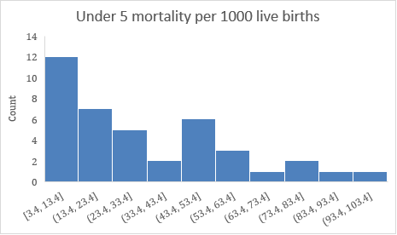

Mean: 32.31

Median: 25.65

Standard deviation: 25.04

Graph 1.1: Distribution of under 5 mortality in 40 countries

The sample distribution for the 40 countries is not symmetric. The shape and the fact that the mean is much higher than the median shows that the distribution is positively skewed. This suggests there are a small number of countries with very high under 5 mortality rates.

Ivory Coast has the maximum under 5 mortality per 1000 live births (98). This represents almost 10% of the live births in that country. In comparison, Australia has the minimum mortality in the sample (3.8), with a mortality rate of 0.4% of every 1000 live births

|  |  |  |  |  |
| --- | --- | --- | --- | --- |
| **Variable** | **Mean** | **Std.Dev** | **Min** | **Max** |
| **Water** | 85.7% | 17.5 | 36.6% | 100% |
| **Sanitation** | 70.7% | 28.64 | 13.95% | 100% |

Table 1.1 Summary statistics of explanatory variables

These summary statistics of the independent variables show that sanitation has a much wider variability than water in this sample.

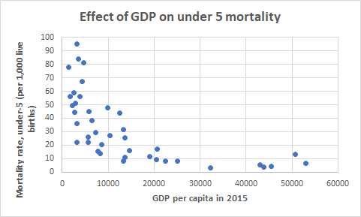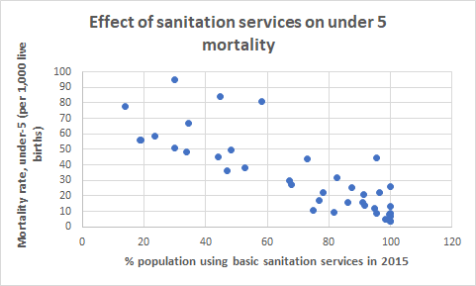 **Scatter plots of each explanatory variable against mortality:**

Graph 1.2 GDP per capita and under 5 mortality for 40 countries

Graph 1.3 GDP per capita and sanitation for 40 countries

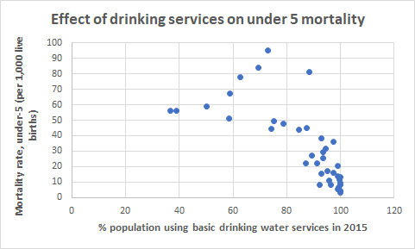

Graph 1.4 GDP per capita and water for 39 countries

All the explanatory variables appear to be negatively correlated with under 5 mortality. The relationship between GDP per capita and under 5 mortality looks to be nonlinear. A log - level transformation can be applied to reduce the effect of the extreme large values of GDP.

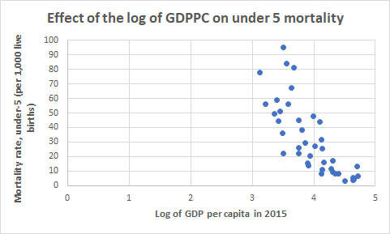

Graph 1.5 GDP per capita and under 5 mortality after log transforming GDP per capita

The relationship appears to be more linear after the transformation. Now a linear regression model can be estimated with all the variables against under 5 mortality.

**The estimated regression model is:**

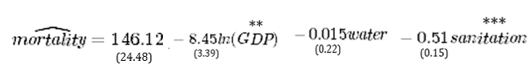

**\*\* Denotes 5% significance ***denotes 1% significance**

**R- square = 0.754**

**Interpretation of this model:**

A 1% increase in GDP per capita is expected to decrease mortality by 0.085 per 1000 live births.

A 1% increase in the percentage of the population using basic drinking water services is expected to decrease mortality by 0.015 per 1000 live births.

A 1% increase in the percentage of the population using basic sanitation services is expected to decrease mortality by 0.51 per 1000 live births.

To see whether water and sanitation are significant determinants of mortality, two t-tests can be conducted: One for water and then for the sanitation.

sanitation = 0

sanitation 0

T-stat = -3.49

The chosen significance level is 5%

T­crit = -2.042

T-stat < Tcrit so reject the null hypothesis thatsanitation = 0. There is sufficient evidence to say that sanitation has an effect on under 5 mortality.

water = 0

water 0

T-stat = -0.066

The chosen significance level is 5%

T-crit = -2.042

T-stat > Tcrit so the null hypothesis is not rejected. There is insufficient evidence to say that water has an effect on under 5 mortality. It is important to note that water is significant in a regression with mortality and the log of GDPPC. This suggests a large degree of correlation between sanitation and water.

To see if water and sanitation are jointly significant in determining under 5 mortality after controlling for GDP per capita, an F-test can be conducted

water sanitation = 0

$H_{1}:$ At least one of water or sanitation is not equal to 0

The test statistic comes from the F distribution:

$R_{ur}^{2}$ = 0.754

$R_{r}^{2}$ = 0.607

F-Stat = $\frac{(0.754-0.607)/2}{(1-0.754)/(39-3-1)}$ = 10.46

The chosen significance level is 5%:

$F_{crit}=$ 3.32

F-Stat > $F_{crit}$. There is sufficient evidence at the 95% significance level which suggests that water and sanitation are jointly significant in explaining under 5 mortality.

The R-square value suggests 75.4% of variation in under 5 mortality can be explained by variation in log of GDP per capita, sanitation and water.

**b)** In order to determine whether water or sanitation has a greater effect in decreasing mortality, a technique called reparameterisation can be used.

This involved regressing mortality on a constant, log(GDP), (water + sanitation) and sanitation. Note: One country does not have water data for 2015 so this country is not included. (df = 35)

Another hypothesis test will be conducted:

sanitation - water =0

sanitation - water < 0 (if sanitation has a greater effect on mortality since the coefficients are negative)

T-stat = -1.48

The chosen significance level is 95%

= -1.70

T35 < T- stat. There is insufficient evidence to reject the null hypothesis that sanitation and water have the same effect on mortality at 5% significance

Despite the negative results of the hypothesis test, water does not appear to have a significant effect on under 5 mortality after controlling for sanitation and the log of GDP per capita.

**Conclusion:**

All in all, there is substantial evidence to support that the level of GDP would indicate the level of sanitation and water services available in a nation. A nation with higher GDP theoretically would have lower mortality rate of children under 5 as they have greater access to sufficient sanitation and clean water as compared to a developing country.

The World Health Organisation’s (WHO) findings entitled, ‘Safer Water, Better Health’ argues that “one tenth of global disease burden” can be eliminated through enhancements in water and sanitation management (Furman, Morjaria & Roseen, 2014, p4). To improve the overall health of the nation, Non-Government Organisations (NGOs) may implement projects to improve the overall sanitation and water quality in developing nations. Whilst research shows that water bone diseases such as diarrhea was the 2nd leading cause of death in children under 5, that is, 1 child died due to diarrhea every 1 minute in 2012 (Furman, Morjaria & Roseen, 2014), the study found that sanitation led to a greater effect on mortality compared to water quality.

The t-test concluded that there is insufficient evidence to prove that water quality has an effect on the under 5 mortality rate. Therefore, NGOs should concentrate on improving sanitation services as it will have a greater effect to decreasing the under 5 mortality rate in developing nations for the same amount of people within the same cost range. Fundamentally, it can be derived that sanitation services have the greatest impact on mortality rates of children under 5. Some of the initiatives NGOs can engage with to improve sanitation services would be to expand the funding of research and development in the area of sanitation to create significant processes of sanitation in developing countries. Moreover, NGOs should also engage in creating a sustainable and a systematic approach to reaching out to more market segments of the society in developing countries.

As Non-Government organisations work tirelessly to better the world, we have already noticed their impact in helping to improve sanitation by providing proper toilets. Although this may seem simple, defecating outside can lead to contamination of both food and water, a simple toilet and sewerage system within towns may save many lives of both the young and aging population. Even simply educating children on safe hygiene practices will eventually spread, education is important and by informing nations on the possible threats of current practices and teaching them new ways, together we can save lives.

**Bibliography:**

* Ferrie, J.P, & Troesken, W. (2008). Water and Chicagoís mortality transition, 1850-1925. *Explorations in Economic History, 45*, 1-16, <http://dx.doi.org/10.1016/j.eeh.2007.06.001>
* Kesztenbauma, L. & Rosenthal, J-L. (2017). Sewers’ diffusion and the decline of mortality: The case of Paris, 1880–1914. *Journal of Urban Economics, 98,* 174-186, <http://dx.doi.org/10.1016/j.jue.2016.03.001>
* World Health Organization. (2018). *Lack of water and inadequate sanitation*. [online] Available at: http://www.who.int/ceh/risks/cehwater/en/ [Accessed 12 Sep. 2018].
* Furman, D., Morjaria, M., & Roseen, D. (2014). The effects of water access on government health care spending worldwide. *Georgia Institute of Technology,* 1-18

**Appendix:**

Appendix 1.1: List of countries

|  |
| --- |
| Algeria |
| Argentina |
| Armenia |
| Australia |
| Bangladesh |
| Bolivia |
| Brazil |
| Canada |
| Chile |
| China |
| Ivory Coast |
| Denmark |
| Dominican Republic |
| El Salvador |
| Guatemala |
| India |
| Indonesia |
| Kenya |
| Kyrgyz Republic |
| Lebanon |
| Malaysia |
| Mauritania |
| Namibia |
| Pakistan |
| Panama |
| Papua New Guinea |
| Paraguay |
| Romania |
| Saudi Arabia |
| Senegal |
| South Africa |
| Spain |
| Sudan |
| Tajikistan |
| Tanzania |
| Togo |
| Uganda |
| USA |
| Uzbekistan **(removed from regression)** |
| Vietnam |

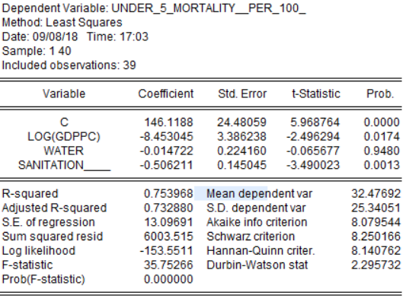Appendix 1.2 Multiple regression output from Eviews

Appendix 1.3 Reparameterisation regression

